Homework M6: Transition to GitOps
Main goal is to build further on what was demonstrated during the practice
Prerequisites may vary between different tasks. You should adjust your infrastructure according to the task you chose to implement

Task
Explore further the GitOps principles by executing the following
- Take the simple counter application (without DB dependencies) from the earlier modules (no matter the language) and create a repository for it (counter-app)
- Prepare a Helm chart for the application and store it in another repository (counter-infra)
- Create an end-to-end Gitea Actions workflow or Jenkins pipeline that has a lint (simple Dockerfile linter), test (simple curl-based test), build and push, and change stages
- Define Argo CD application that interacts with the infrastructure repository
* The focus should be on achieving the required and not on doing it in the most automated way possible

Proof
Prepare a document that shows what you accomplished and how you did it. It can include (not limited to):
- The commands you used to achieve the above tasks
- A few pictures showing intermediary steps or results

0. Creating folder structure for the app of my choosing (I chose python-counter-app)
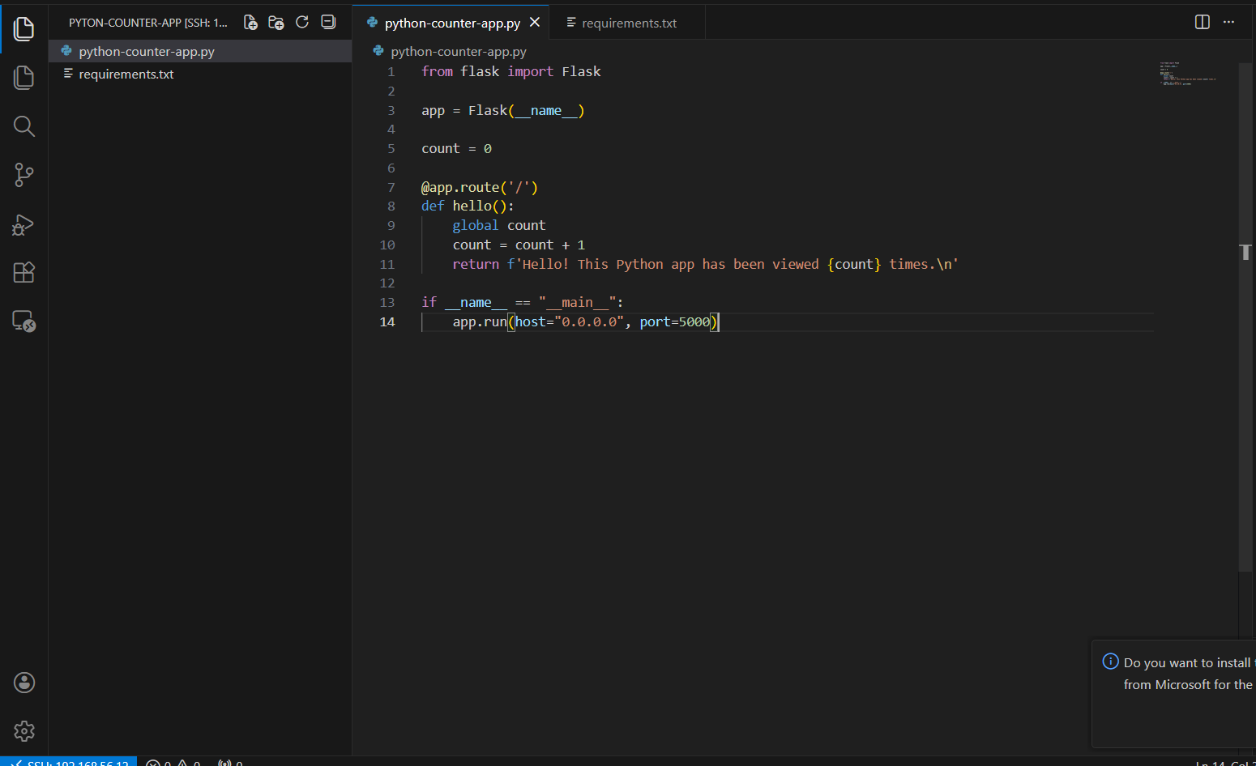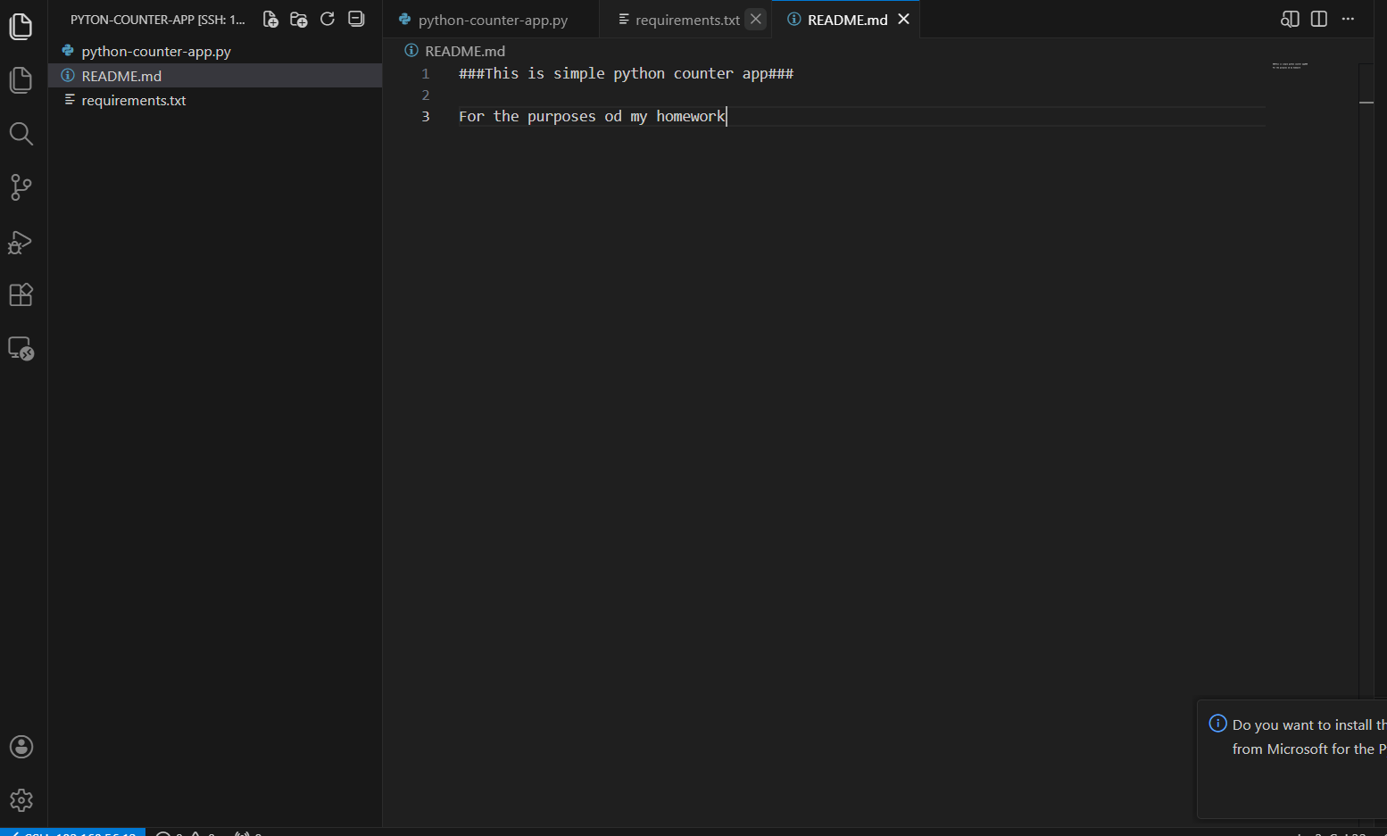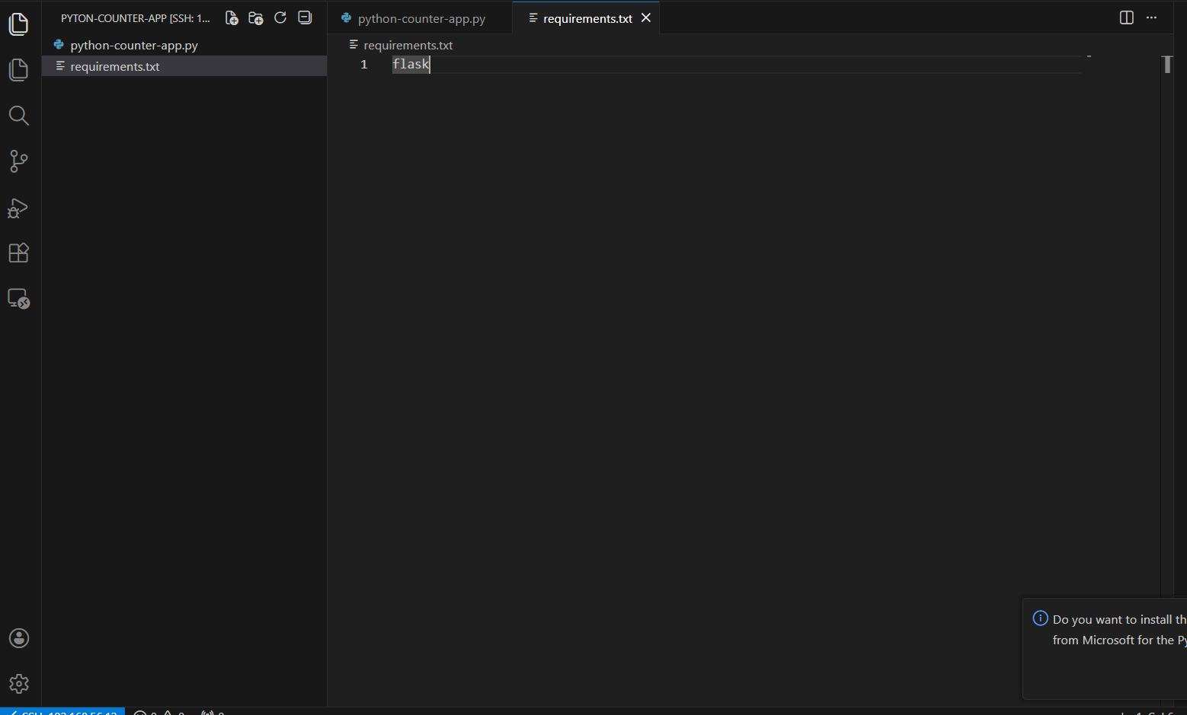
- Creating the gitea repository for the application
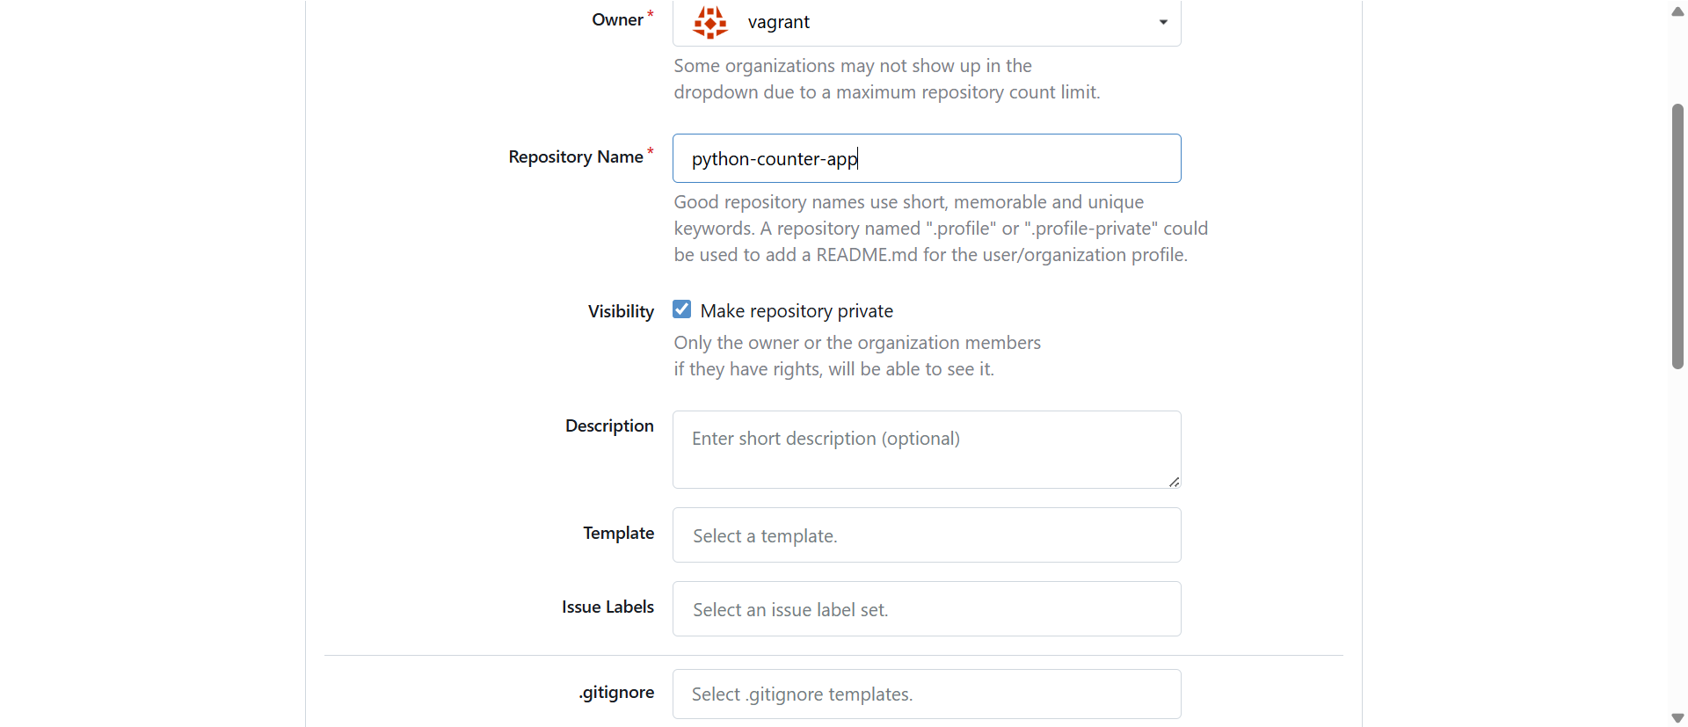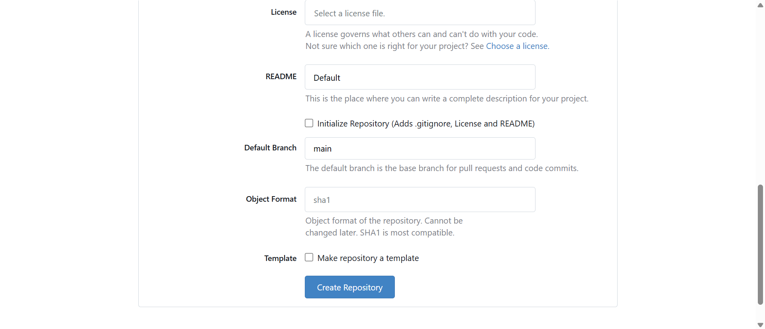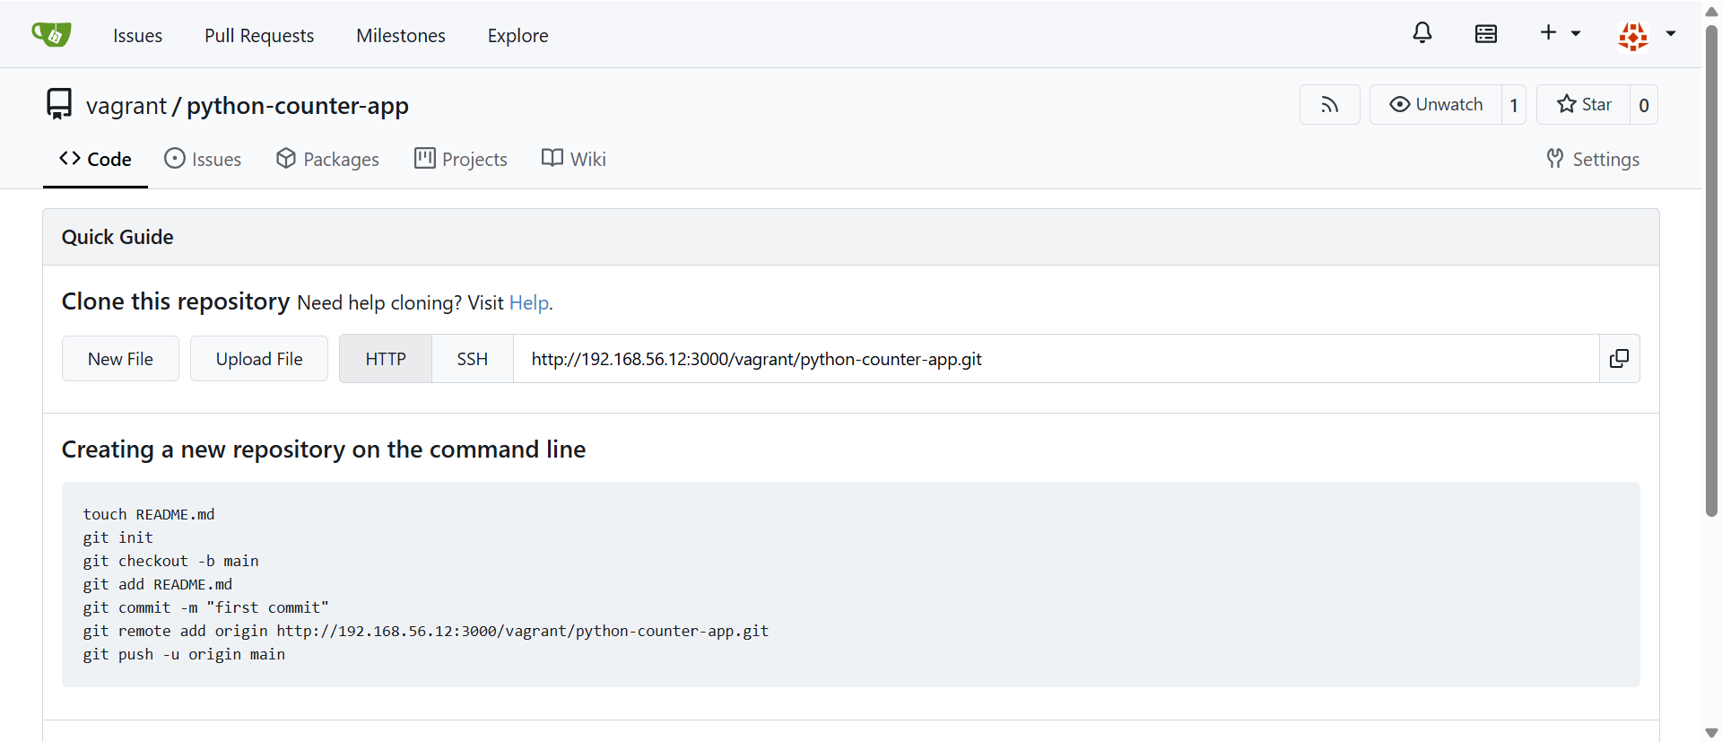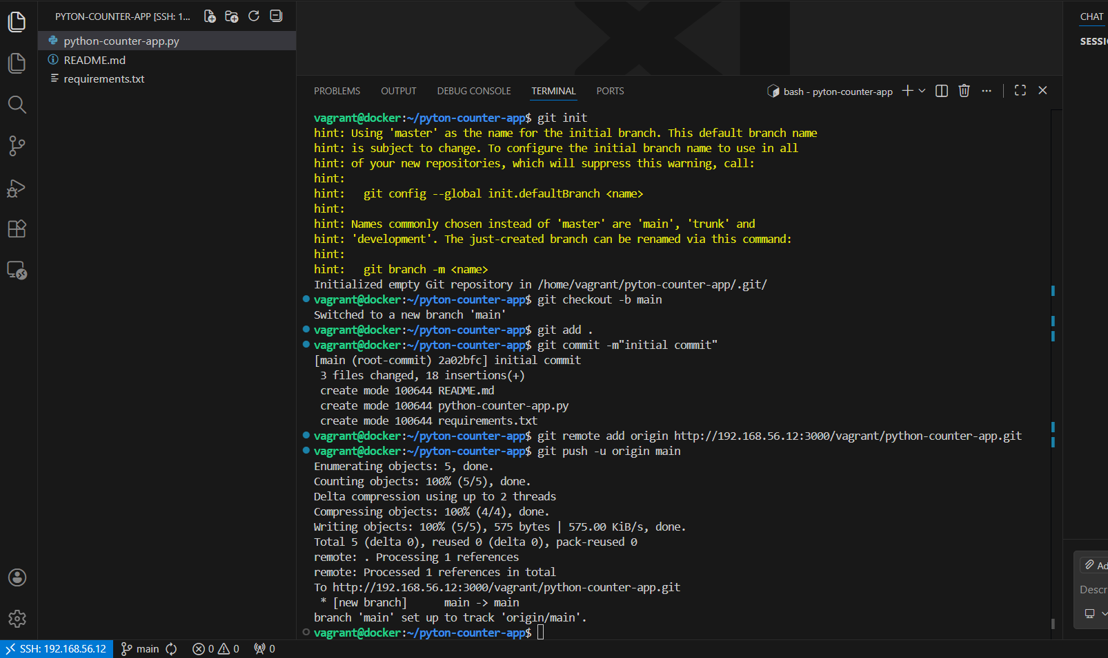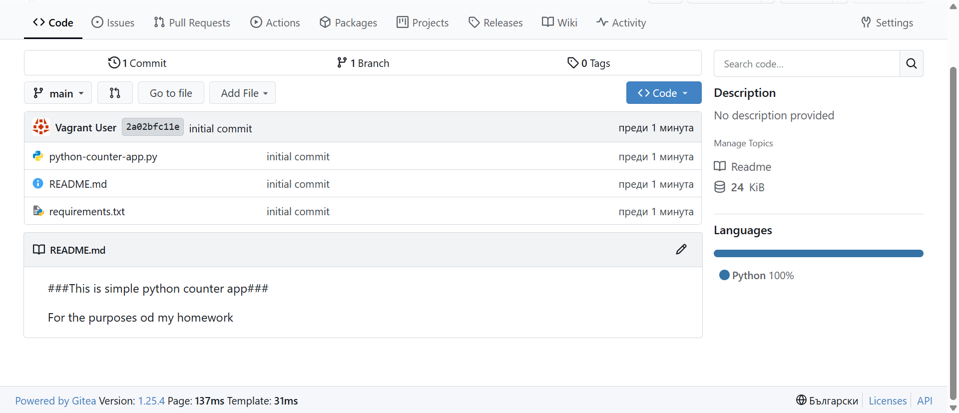

2.Creating Gitea workflow or Jenkins pipeline
2.1 Creating Gitea workflow and dedicated Dockerfile for my application. Adding to the repository
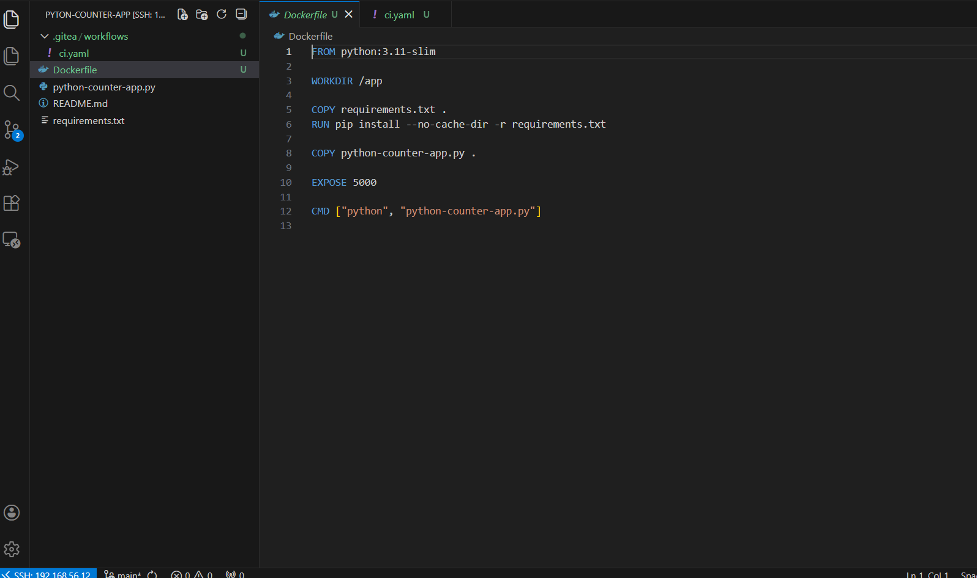
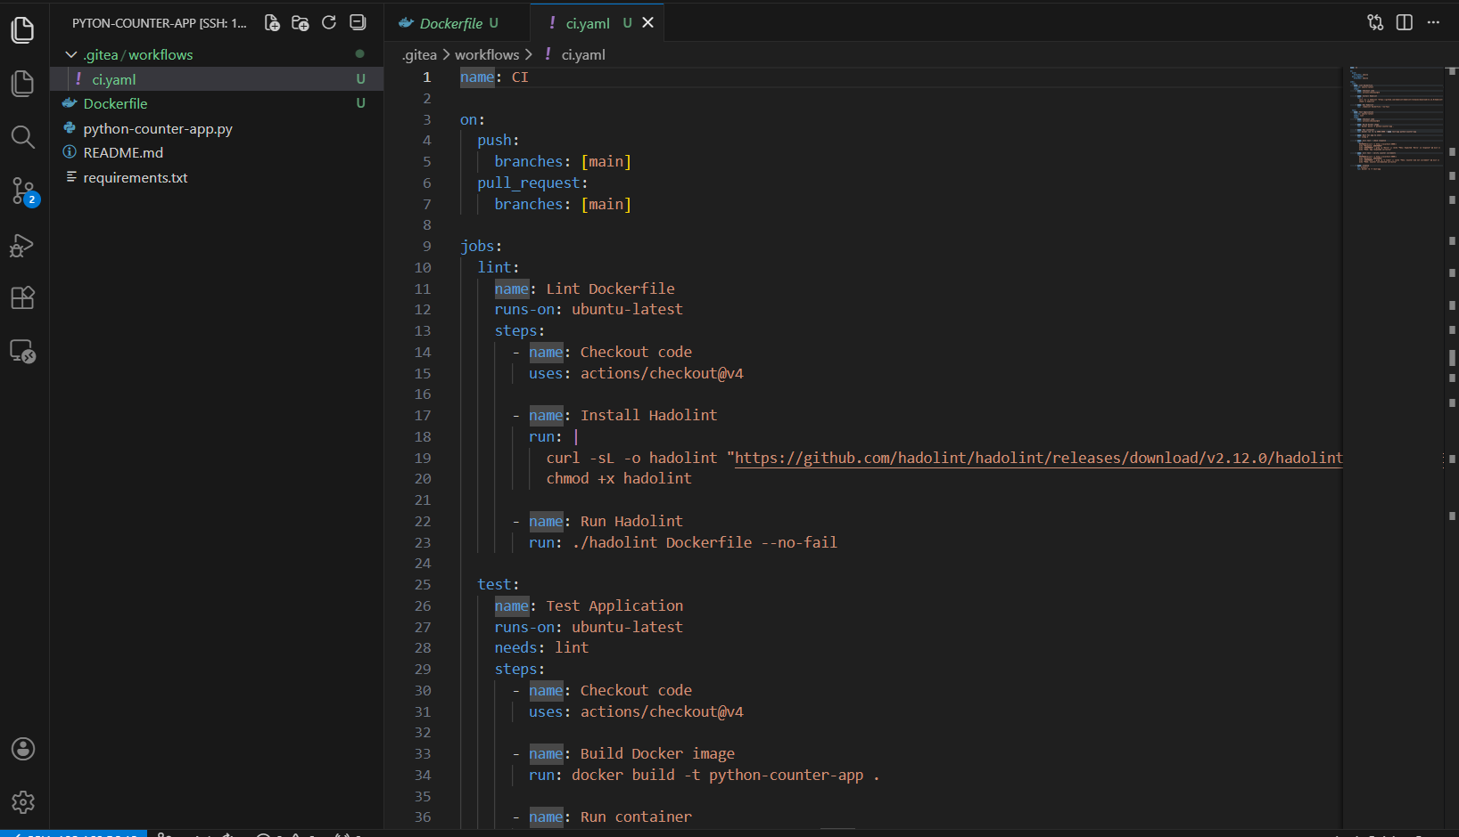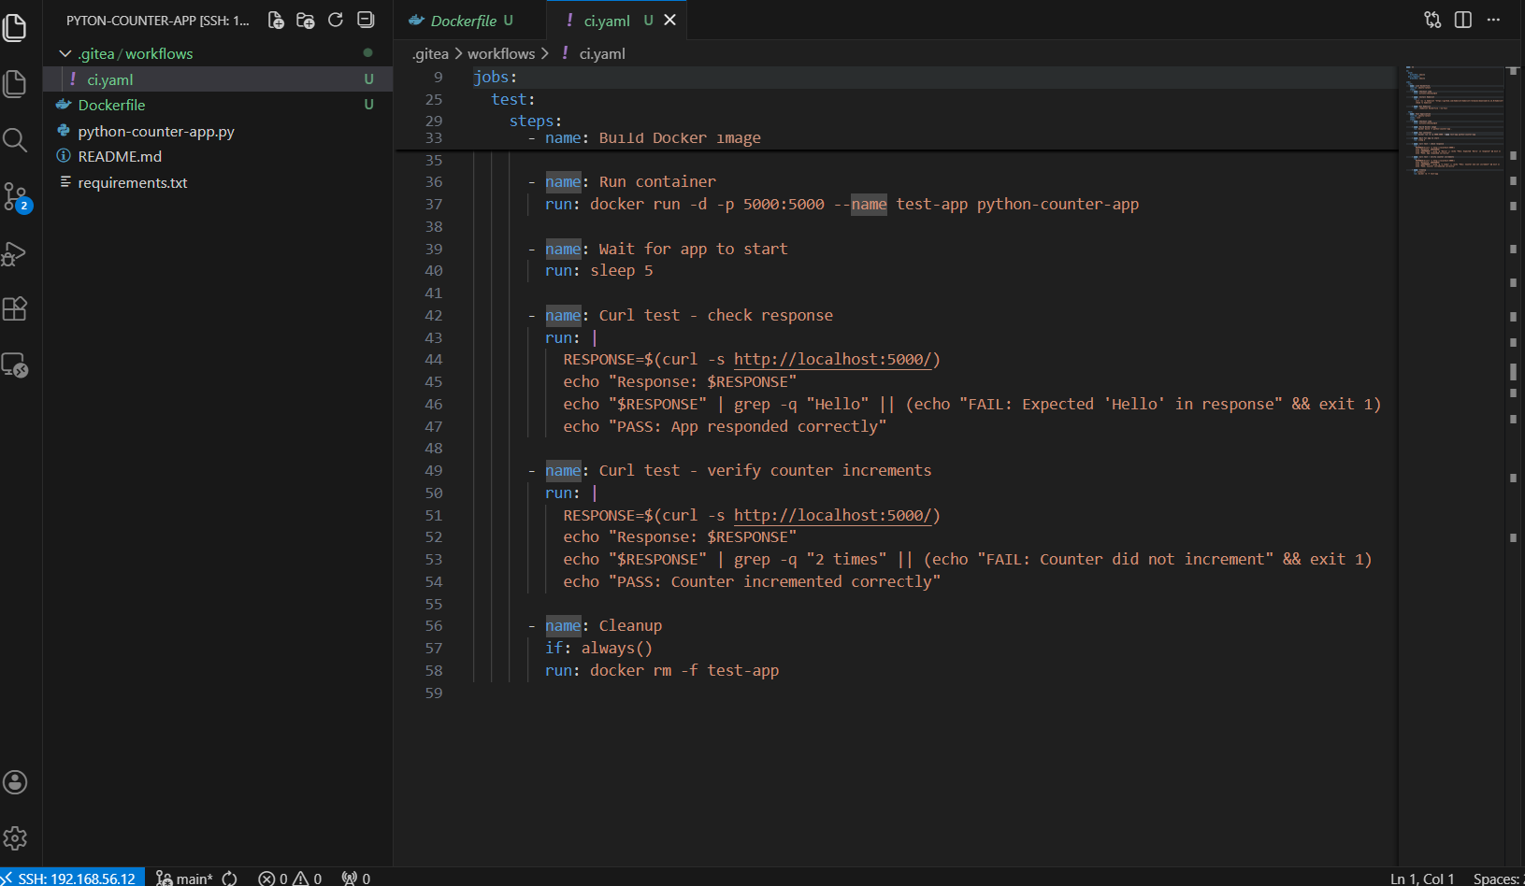
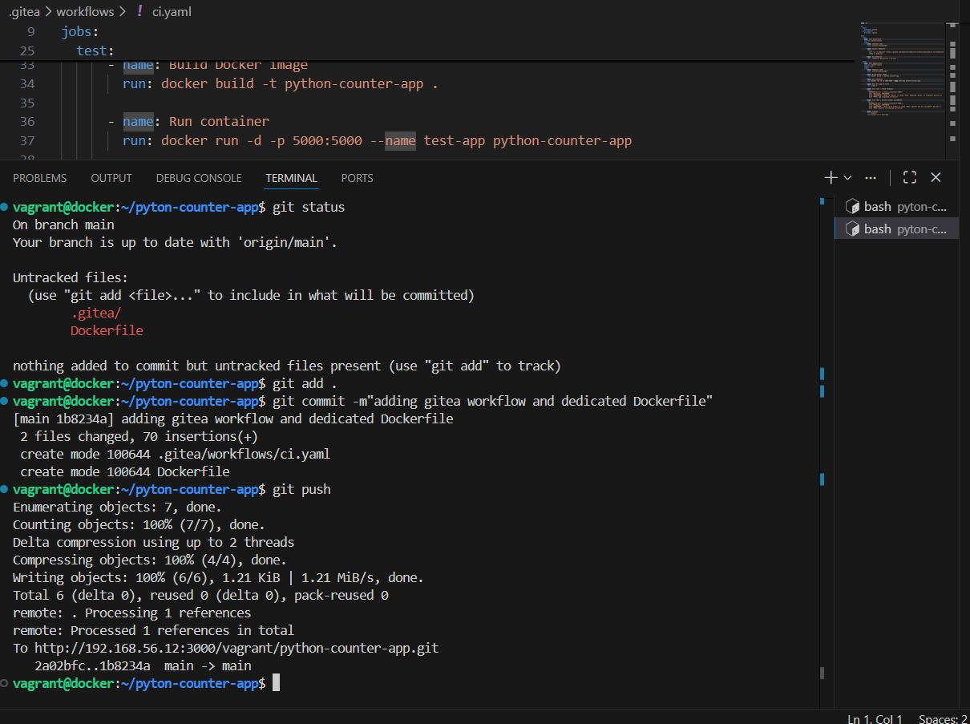
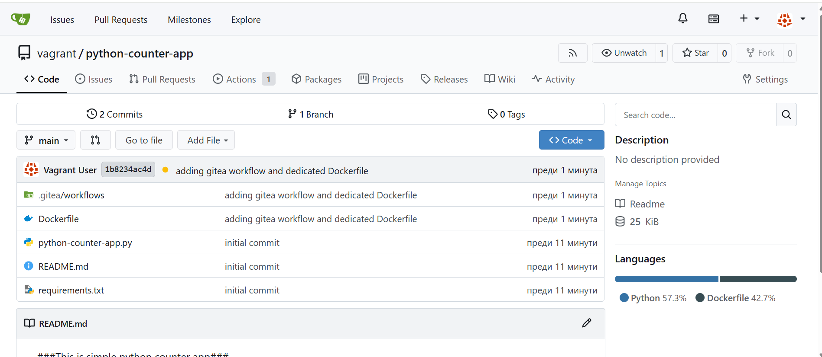
2.2 Creating Jenkins pipeline
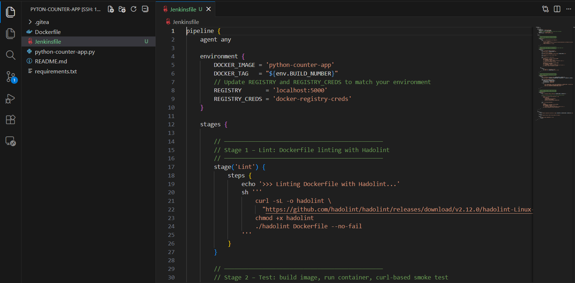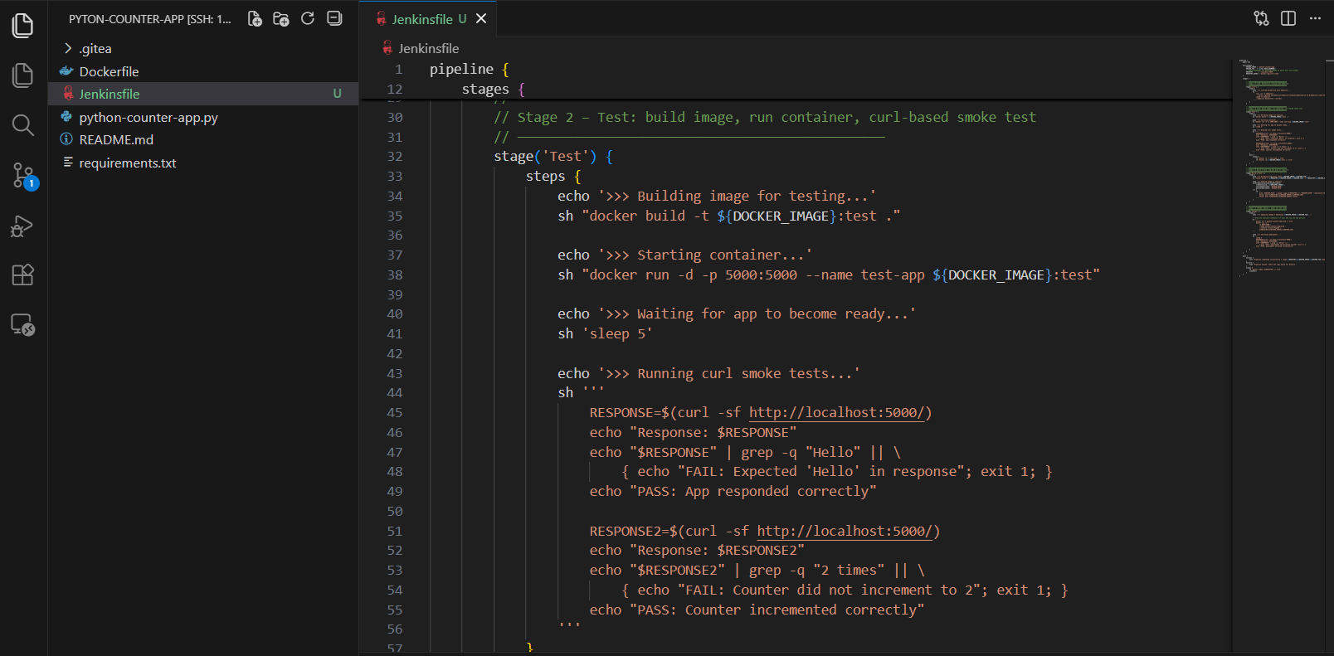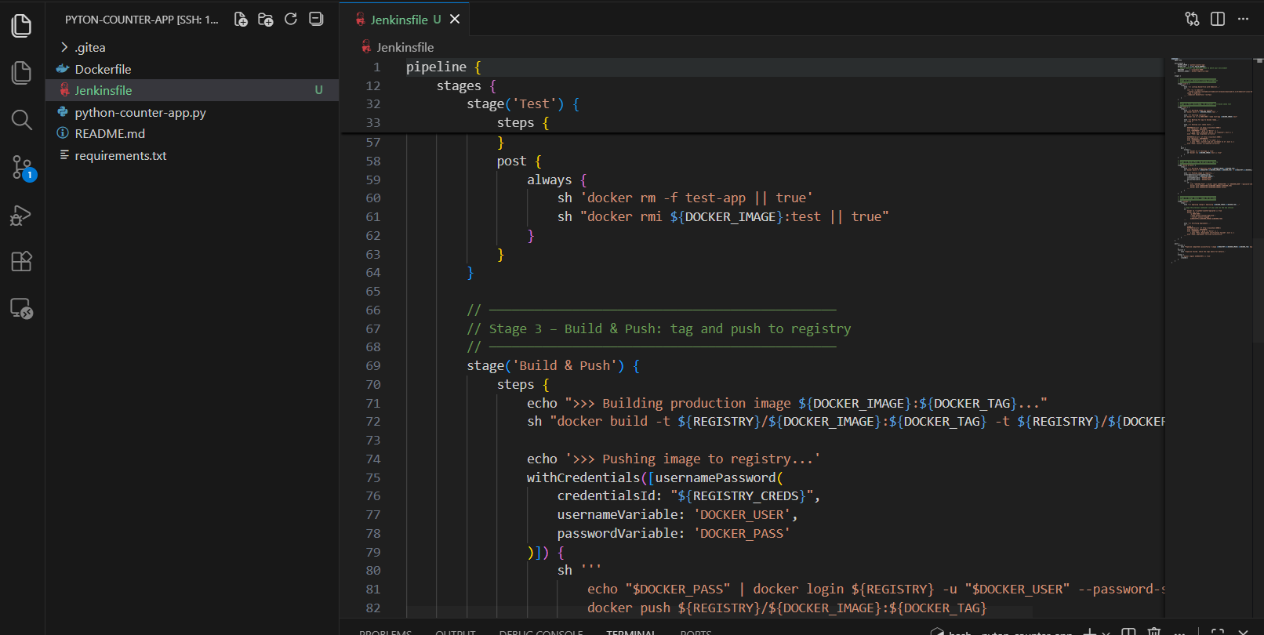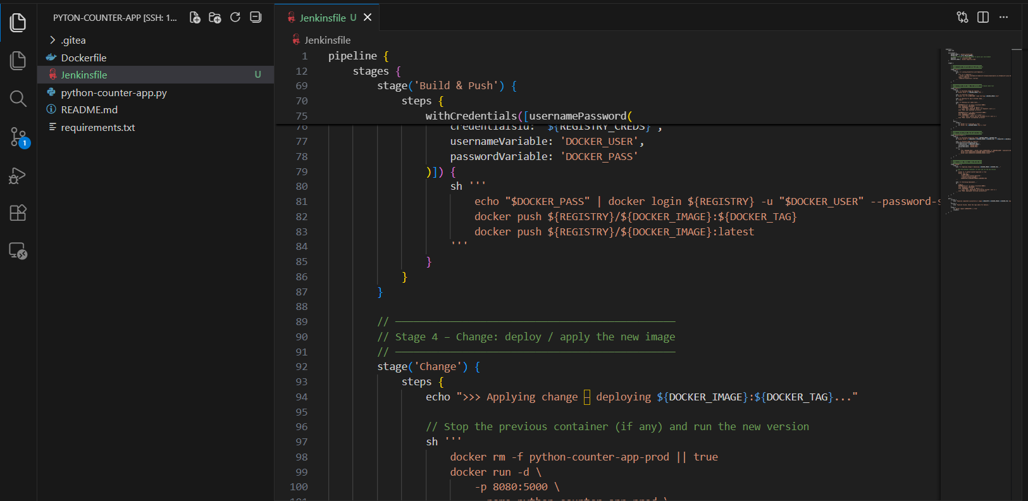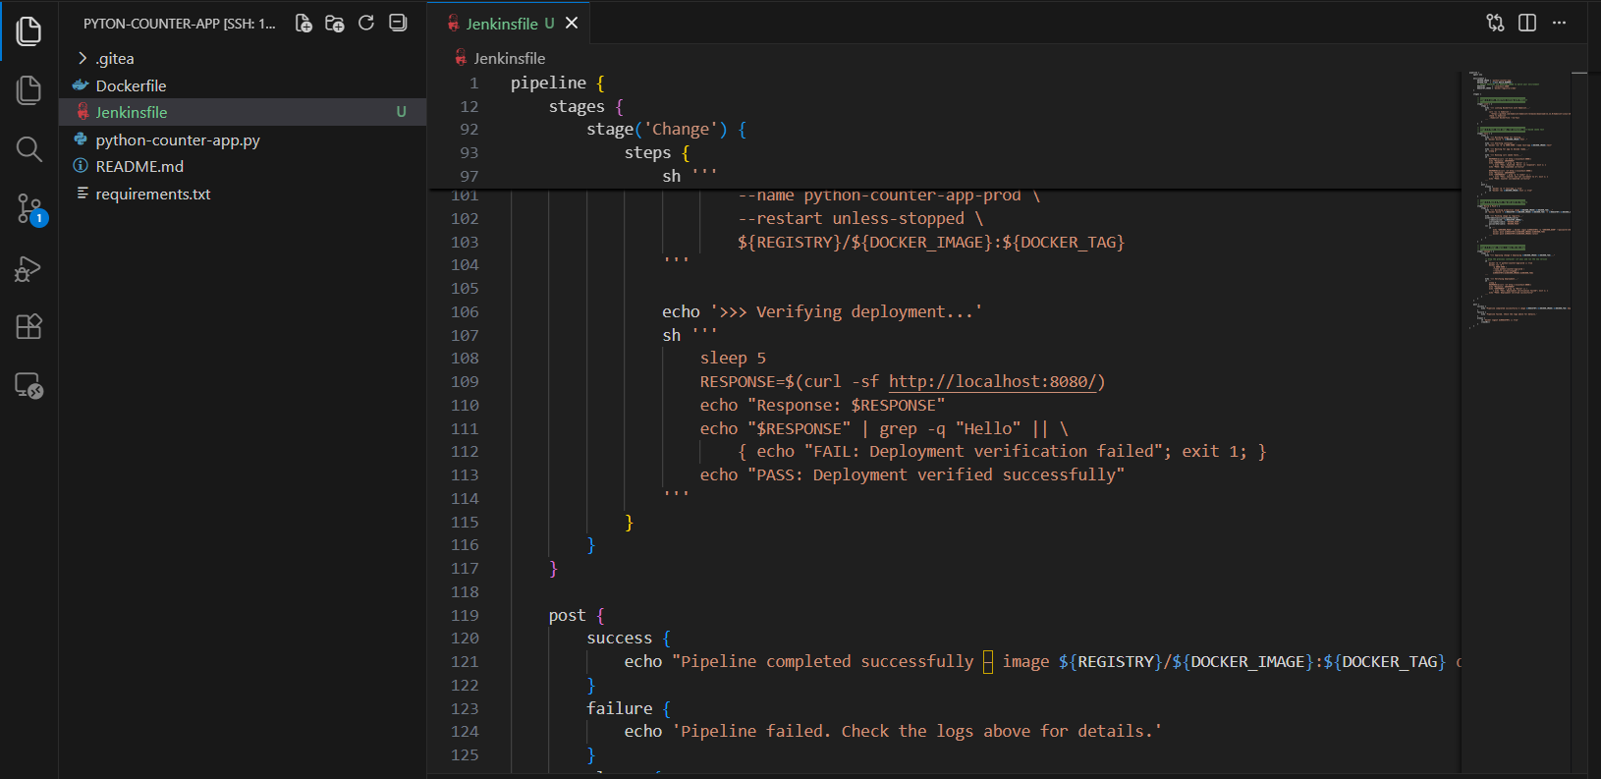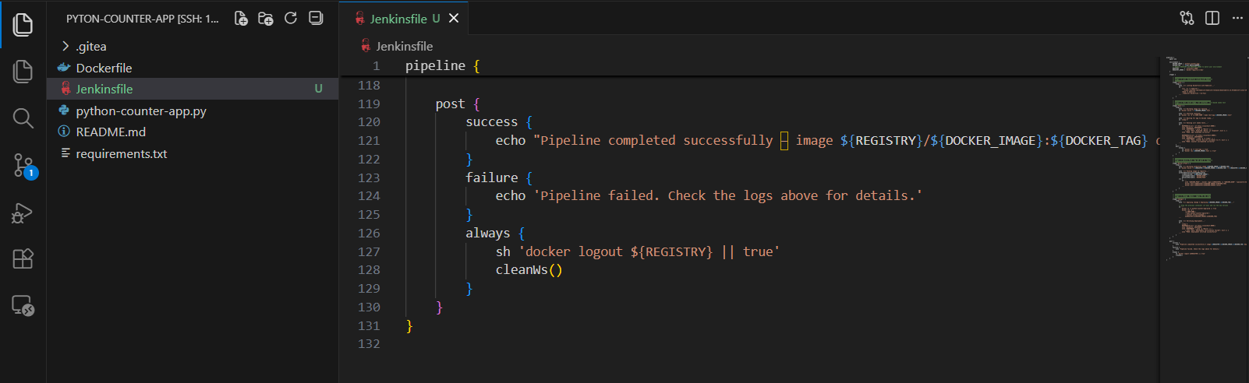
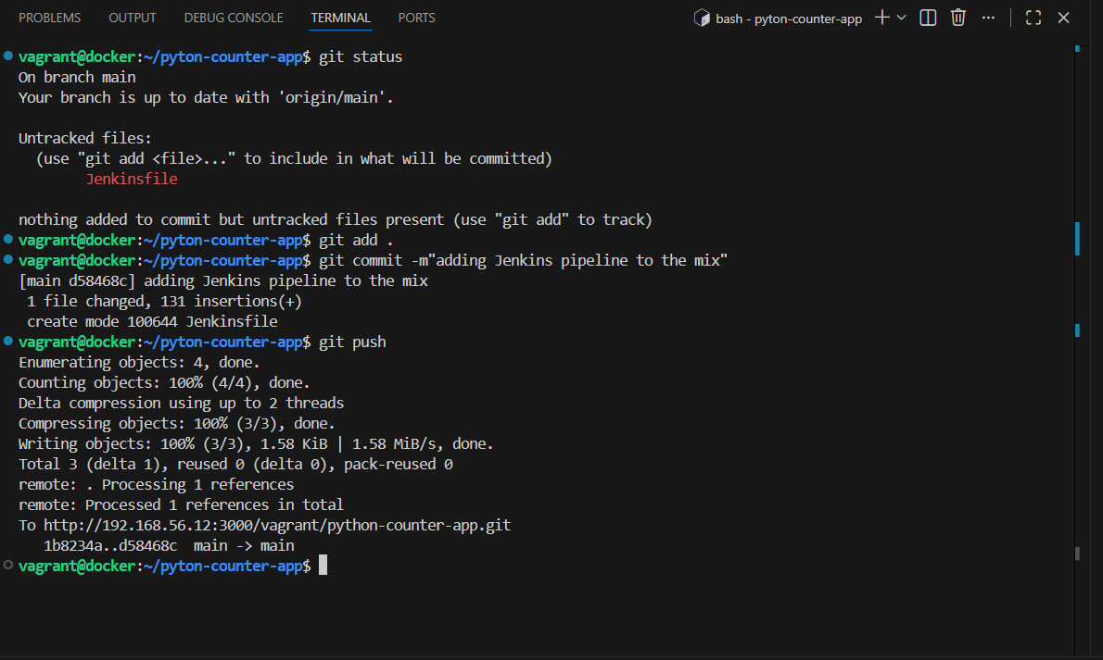
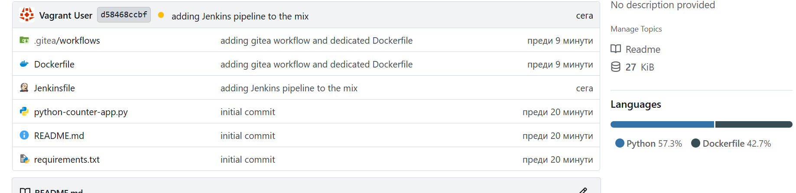
3. Creating Helm chart for python-counter-app and storing it in a brand new repository python-counter-infra
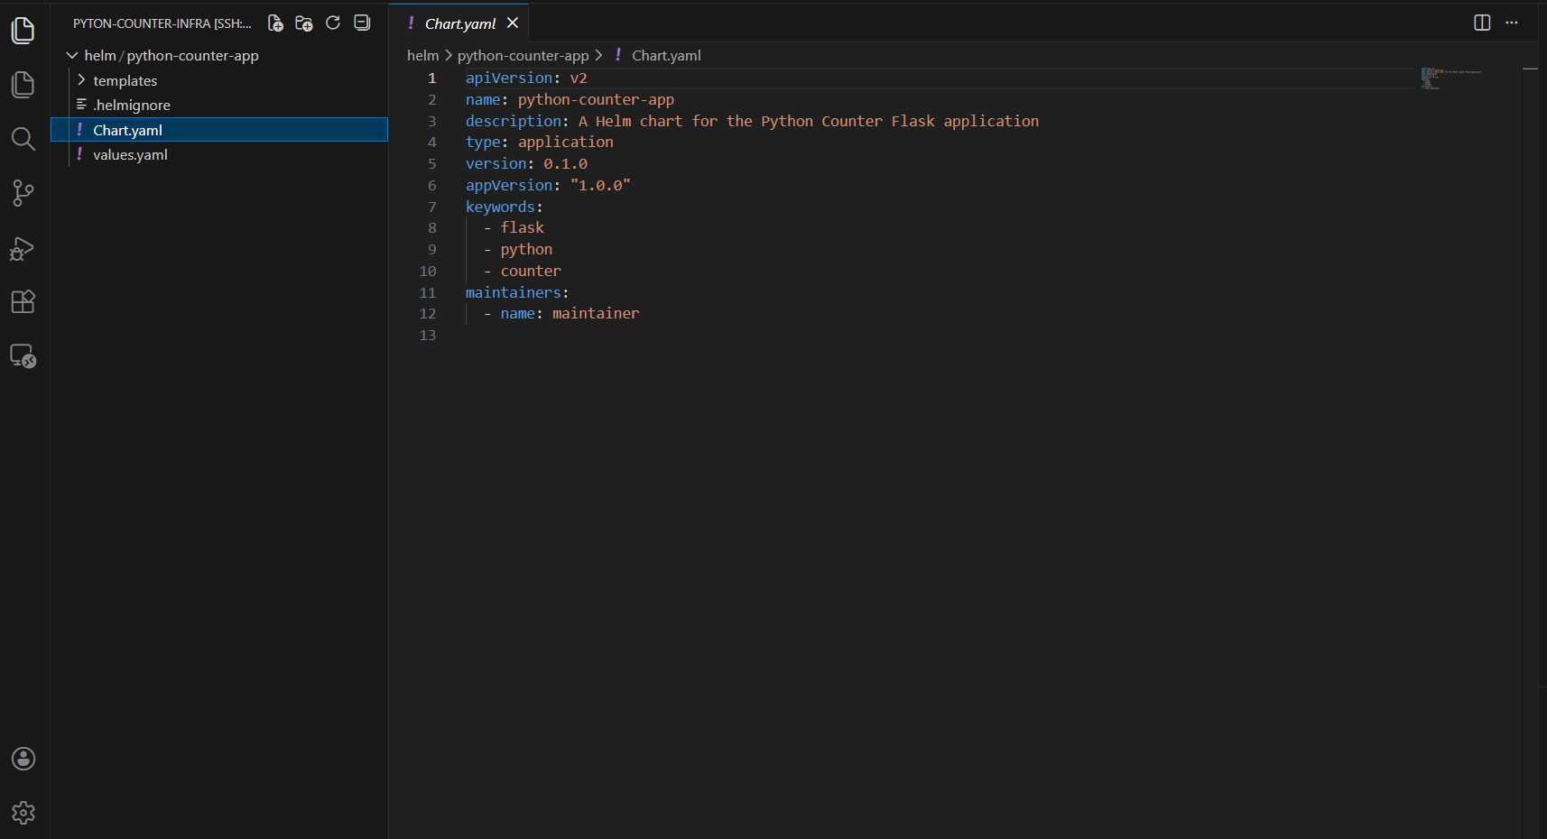
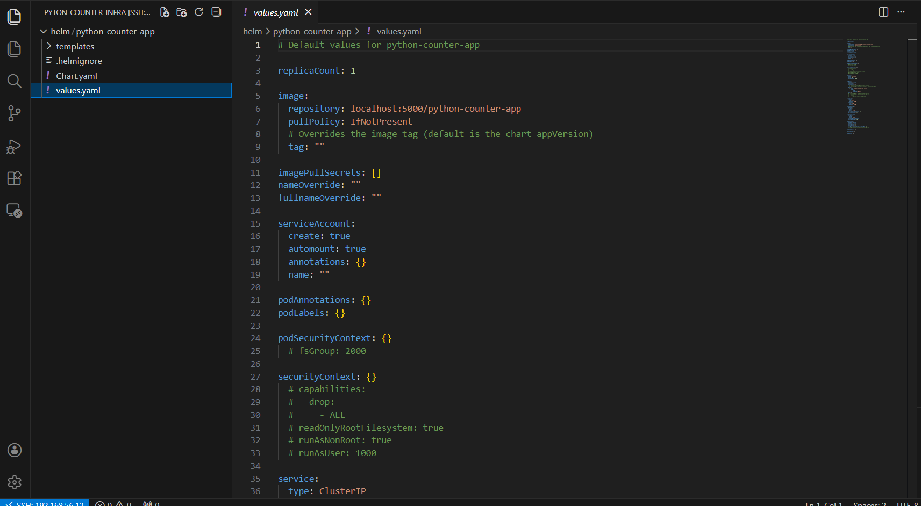
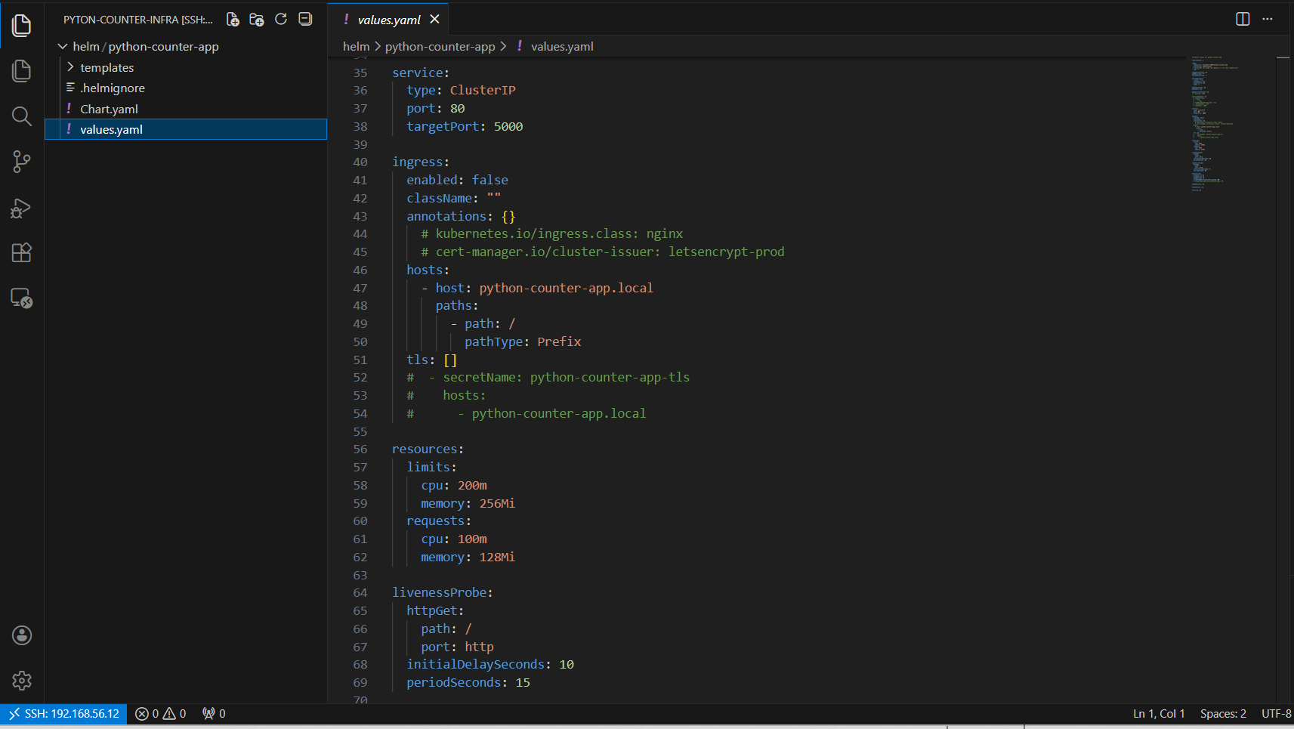
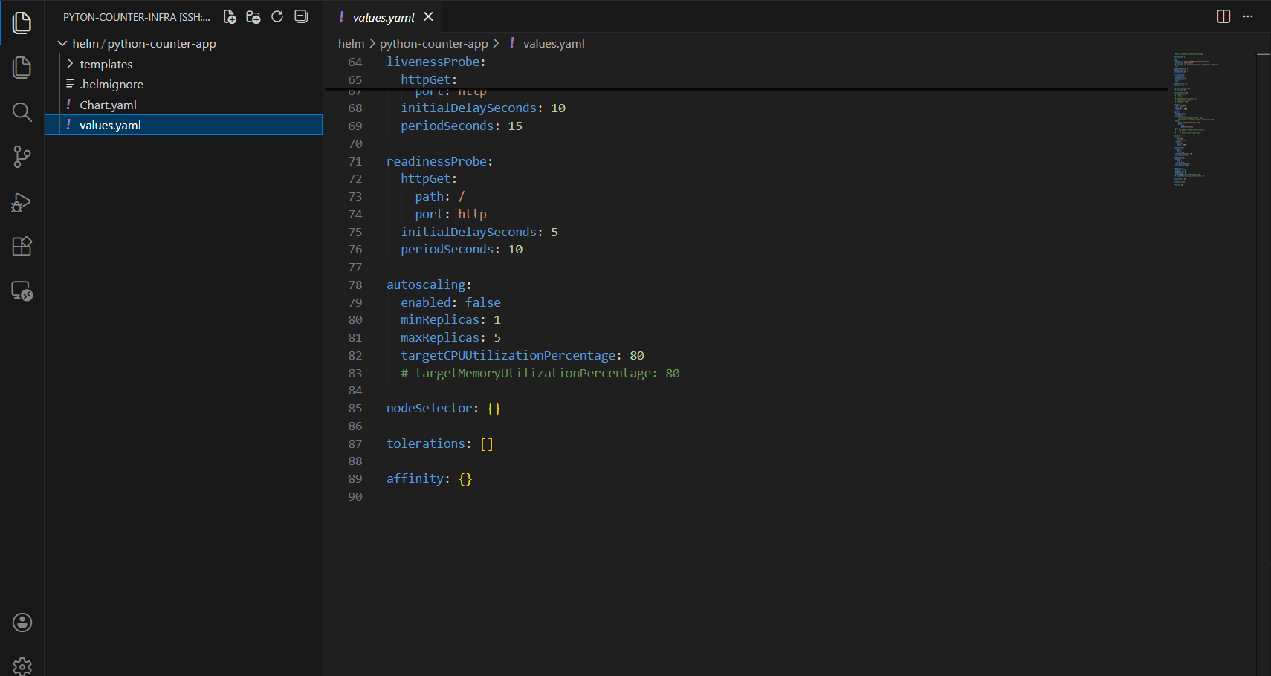
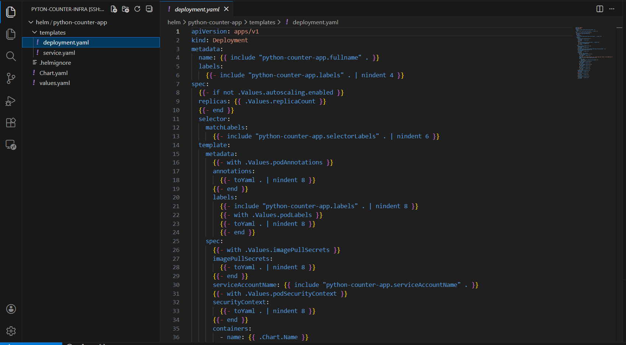
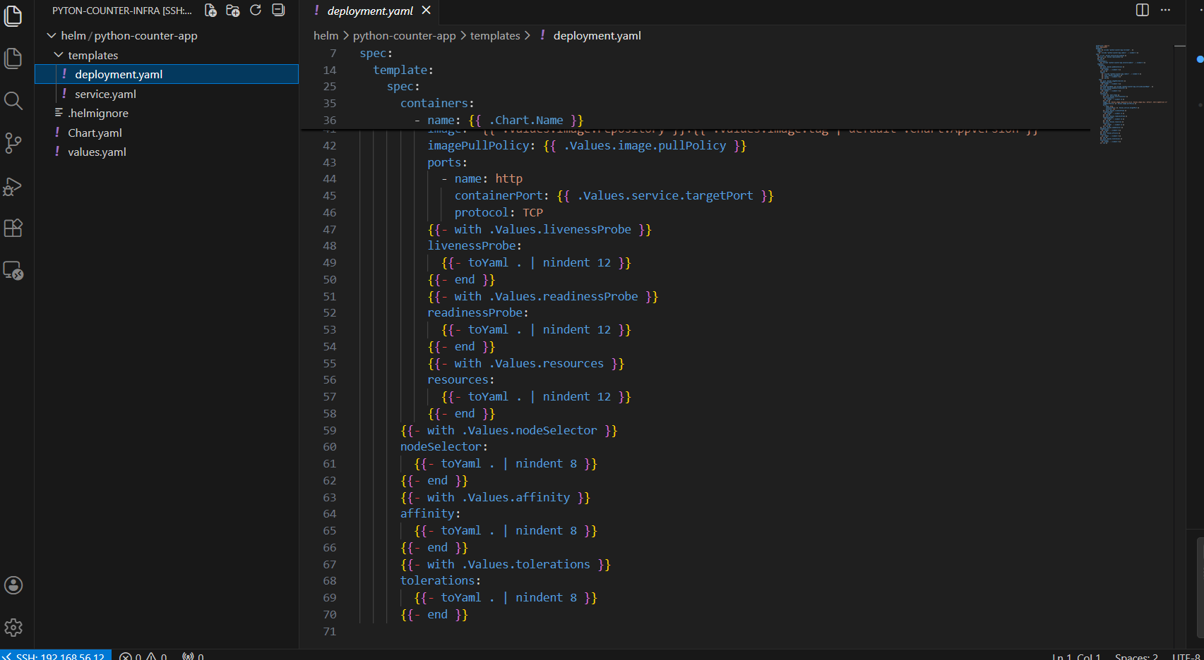
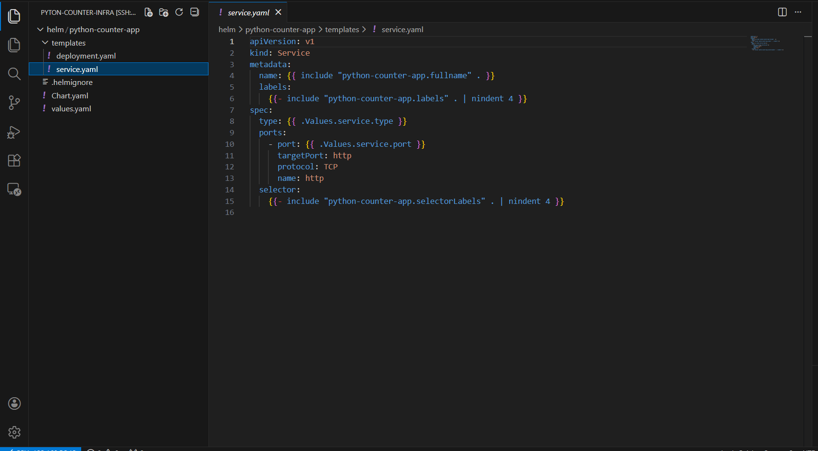
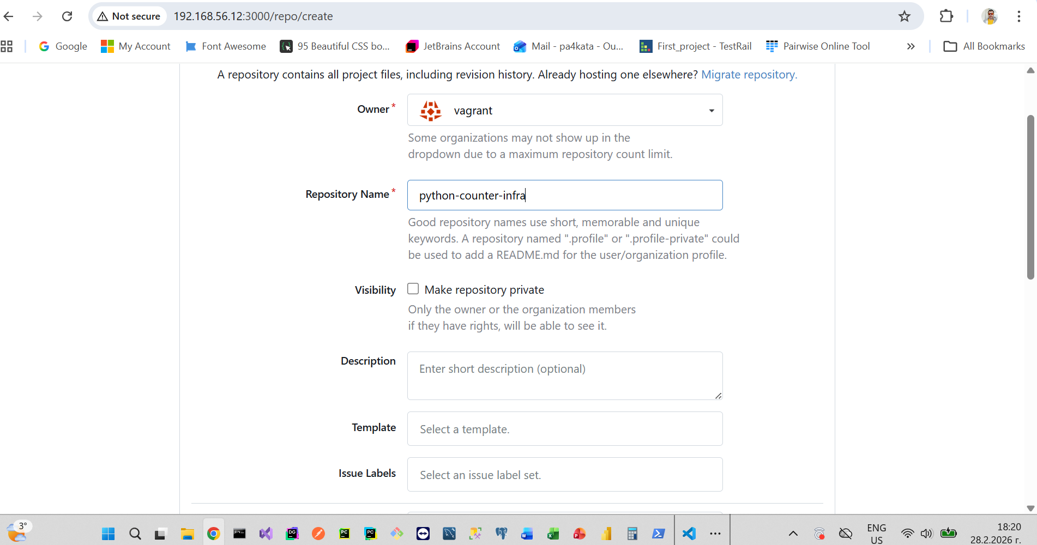
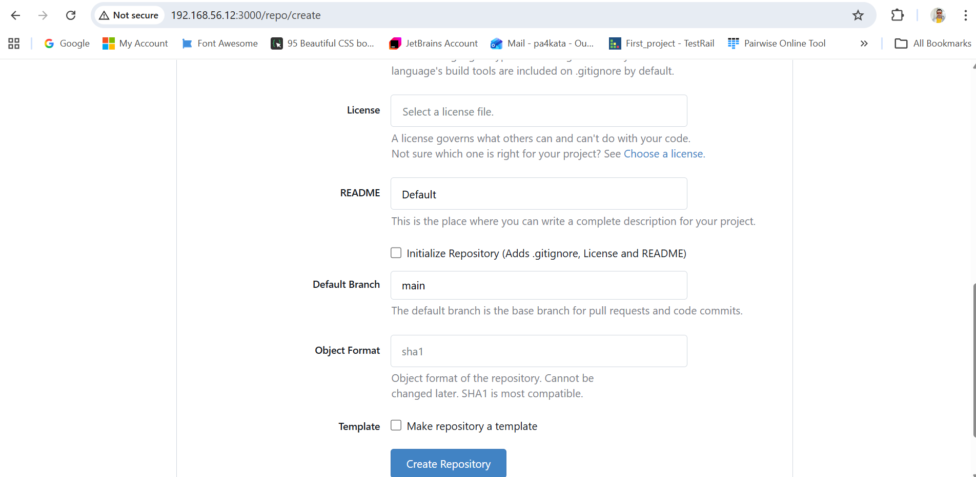
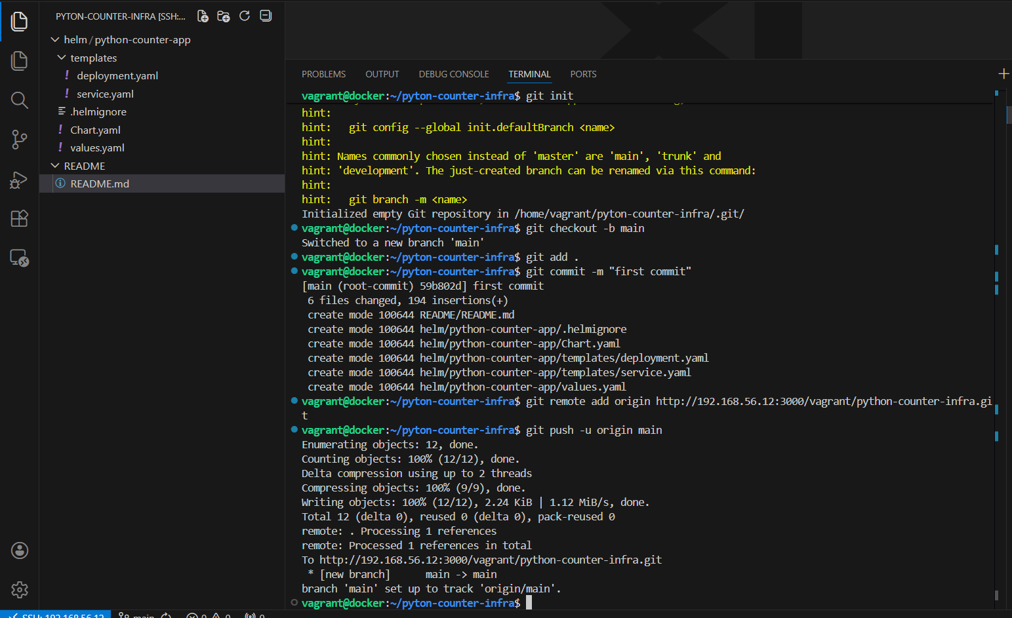
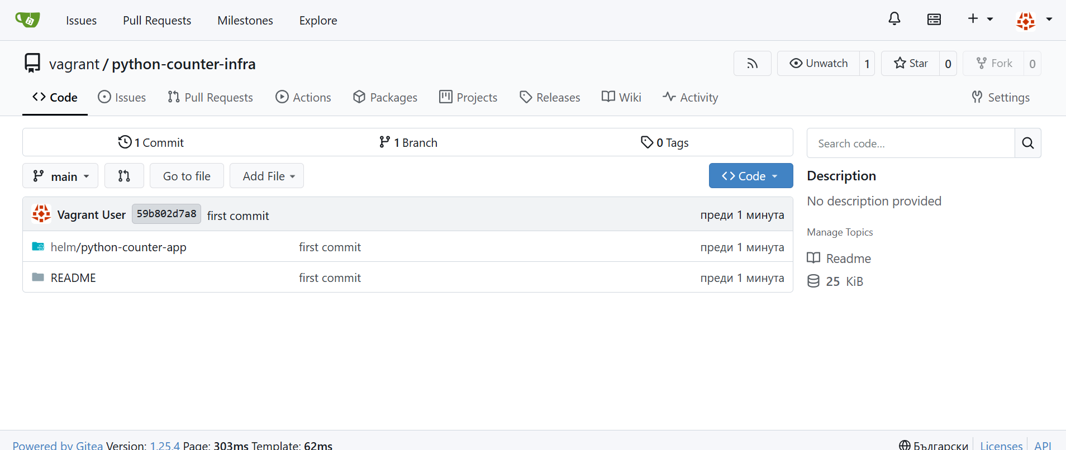
4. Defining argo cd application that interacts with the infrastructure repository
